THE BRITISH SOCIETY FOR CLINICAL NEUROPHYSIOLOGY
(FORMERLY THE EEG SOCIETY)

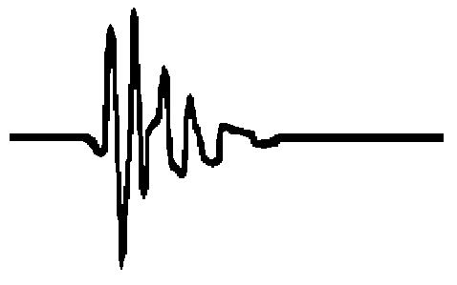
BSCN
Founded as
the EEG Society
in 1942

Application Form - Student Essay Prize

“How neurophysiology assisted in the diagnosis and/or management of a patient?”

Surname:

First name:

Email:

(We will primarily use email to communicate with you)

Address:

University/Medical School:

Year of study:
Number of Words (excluding references, legends, figures and tables)
Please submit your essay & application form email Louise Jones (louiseannjones@btinternet.com)

Please note allowed file types: pdf, doc, docx

